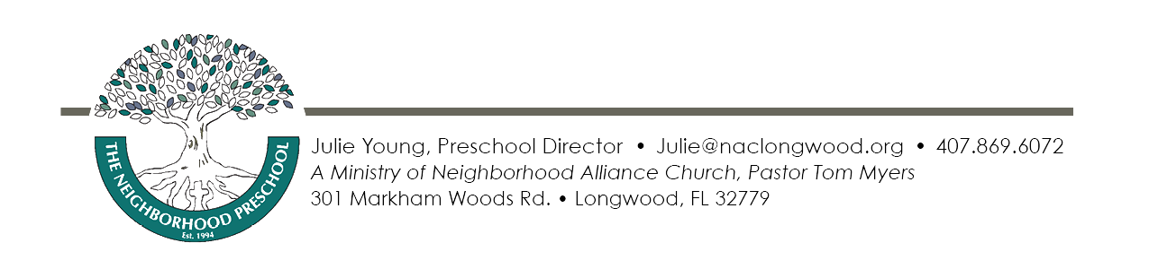 The Neighborhood Preschool
Fee Schedule
August 2019 through May 2020

Preschool Only – T.N.P. Lil’ Learners 9:30-1:30pm

Two Days/Per Week $240.00/$230.00 month 2nd Sibling $215.00/$206.00 month

Three Days/Per Week $328.00/$315.00 month 2nd Sibling $296.00/$284.00 month

Four Days/Per Week $429.00/$412.00 month 2nd Sibling $386.00/$371.00 month

Five Days/Per Week $624.00/$600.00 month 2nd Sibling $483.00/$464.00 month

Preschool Enrichment – T.N.P. Creative Learners 8:30-2:30pm

Two Days Per Week $357.00/$343.00 month 2nd Sibling $321.00/$308.00 month

Three Days Per Week $489.00/$470.00 month 2nd Sibling $440.00/$423.00 month

Four Days Per Week $616.00/$592.25 month 2nd Sibling $555.00/$533.00 month

Five Days Per Week $740.00/$711.00month 2nd Sibling $666.00/$640.00 month

Annual Registration & Curriculum Fees
All tuition fees are due at the beginning of each month. Late fees apply on payments received after the 10th of each month. Make all checks to: The Neighborhood Preschool

Little Learners & Creative Learners
A $104.00 ($156.00/family max.) Non-refundable Registration Fee is required upon registration.
A $104.00 Curriculum Fee is due at Open House/Meet The Teacher Night.
Payment Options: Check, Cash or online payment options are available. A discount of 3-4% applies to all families paying by cash or check on a regular basis. See Fee Schedule!
VPK ONLY classes Meet Tues.-Fri. 9:30 – 1:30pm Only (Fees are waived)
VPK Enrichment Options:
VPK Student Adding Mondays from 9:30-1:30pm Fee: $154.00/$150.00 per month
Attending Tuesday-Friday 8:00 - 3:30pm Fee: $300.00/$289.00 per month
Attending 5 Days M-F 8:00 - 3:30pm Fee: $419.00/$402.00 per month
COE and VPK Enrichment Registration Fee ($104.00) are due upon registration.
VPK Enrichment Students pay a $52.00 Curriculum Fee, due upon enrollment.
Optional Drop In Before Care $9.00 per day per child 8:00am-9:30am
Optional Drop In After Care $12.00 per day/per child 1:30pm-3:30pm
Limited spaces available based on our Creative Learners enrollment.

