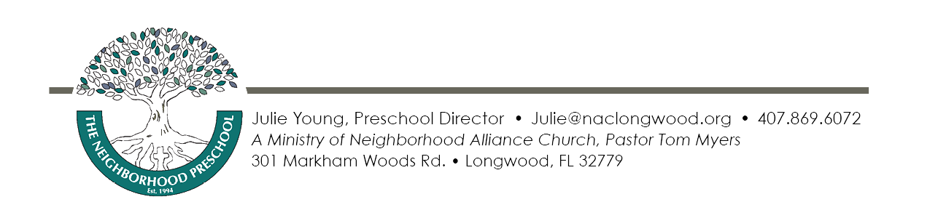
The Neighborhood Preschool
Fee Schedule
August 2019 to May 2020

Preschool Only – T.N.P. Lil’ Learners 9:30am-1:30pm

Two Days Per Week $231.00/month 2nd Sibling $208.00/month

Three Days Per Week $318.00/month 2nd Sibling $286.00/month

Four Days Per Week $413.00/month 2nd Sibling $375.00/month

Five Days Per Week $500.00/month 2nd Sibling $450.00/month

Preschool Enrichment – T.N.P. Creative Learners 8:00am-3:30pm

Two Days Per Week $346.00/month 2nd Sibling $300.00/month

Three Days Per Week $474.00/month 2nd Sibling $410.00/month

Four Days Per Week $598.00/month 2nd Sibling $518.00/month

Five Days Per Week $707.00/month 2nd Sibling $634.00/month

We do have an option to add Mondays only, from 9:30-1:30 for $104.00 per month.
Little Learners and Creative Learners Registration Fee A $104.00 ($156.00/family max.) non-refundable registration fee is required upon registration. A $104.00 Curriculum Fee is due at Open House.
Payment Options: Check, Cash or Debit/Credit card payment options are available. All tuition fees are due at the beginning of each month and late fees apply on payments received after the 10th of each month. Payments can be made on line at www.naclongwood.org/paytuition. Make all checks to: The Neighborhood Preschool.

VPK is 9:30-1:30 T-F if you choose this only, fees are waived
Your options for a VPK student are:

1.) M-F 8:00-3:30 fee is $406.00 per month
2.) T - F 8:00-3:30 fee is $291.00 per month
3.) Add Mondays only, from 9:30-1:30 for $104.00 per month or Monday 8-3:30pm for $144 per month.
We also have the optional drop in before care and aftercare based on availability, but if you need it often, it is more cost effective to opt for the Creative Learners program.
Creative learners adds elements of music and drama in the mornings and the afternoons; we focus more on healthy living, building large motor skills and strengthening our social skills.
There is a registration fee of $104.00 and a VPK Curriculum Fee of $52.00 for students using any additional services or hours beyond VPK Only hours.
Optional Drop In Before Care $9.00 per day/per child
Optional Drop In After Care $12.00 per day/per child
Limited spaces available Based on our Creative Learners enrollment

